**=====**

**Router R1**

Enable

Router# erase startup-config

Router# reload

configure terminal

hostname R1

enable password cisco

line vty 0 4

password cisco

login

exit

exit

R1# copy running-config startup-config

R1# show running-confige

R1#configure terminal

R1(config)#interface g0/0/0

no shutdown

R1(config-if)#ip add 192.168.12.1 255.255.255.0

R1(config-if)#interface g0/0/1

R1(config-if)#no shutdown

R1(config-if)#interface g0/0/1.10

R1(config-if)#no shutdown

R1(config-subif)#encapsulation dot1Q 10

R1(config-subif)#ip add 10.10.0.1 255.255.255.0

exit

**R1(config)#** router ospf 65

**R1(config-router)#** network 10.10.0.0 0.0.0.255 area 0

**R1(config-router)#** network [192.168.12.0](http://192.168.12.0/) 0.0.0.255 area 0

//network [192.168.12.0](http://192.168.12.0/) [0.0.0.255](http://0.0.0.255/) area 0

**Router R2**

Enable

Router# erase startup-config

Router# reload

configure terminal

hostname R2

enable password cisco

line vty 0 4

password cisco

login

exit

exit

R2# copy running-config startup-config

R2# show running-config

R2#configure terminal

R2(config)#interface g0/0/0

no shutdown

R2(config-if)#ip add 192.168.12.2 255.255.255.0

R2(config)#interface g0/0/1

R2(config-if)#no shutdown

R2(config-if)#interface g0/0/1.20

R2(config-subif)#no shutdown

R2(config-subif)#encapsulation dot1Q 20

R2(config-subif)#ip add 10.20.0.1 255.255.255.0

**R2(config)#** router ospf 65

**R2(config-router)#** network 10.20.0.0 0.0.0.255 area 0

**R2(config-router)#** network [192.168.12.0](http://192.168.12.0/) 0.0.0.255 area 0

**Switch S1**

Enable

Switch# erase startup-config

Switch# delete vlan.dat

Switch# reload

configure terminal

hostname S1

enable password cisco

line vty 0 4

password cisco

login

exit

exit

S1# copy running-config startup-config

S1# show running-config

configure terminal

vlan 10

name VLAN10

interface f0/6

switchport mode access

switchport access vlan 10

exit

interface vlan 10

ip add 10.10.0.2 255.255.255.0

interface g0/1

switchport mode trunk

**Switch S2**

Enable

Switch# erase startup-config

Switch# delete vlan.dat

Switch# reload

configure terminal

hostname S2

enable password cisco

line vty 0 4

password cisco

login

exit

exit

S2# copy running-config startup-config

S2# show running-config

configure terminal

vlan 20

name VLAN20

interface f0/6

switchport mode access

switchport access vlan 20

exit

interface vlan 20

no shutdown

ip add 10.20.0.2 255.255.255.0

interface g0/1

switchport mode trunk

=== lệnh Check ===

Tạo default route đi qua cổng g0/0/0

enable

iproute 0.0.0.0 0.0.0.0 192.168.12.2

Quảng bá default static route cho các router khác qua OSPF:  
*router ospf 65  
default-information originate*

*exit*

*exit*

kiểm tra default static route đi qua cổng này:

***show ip route***

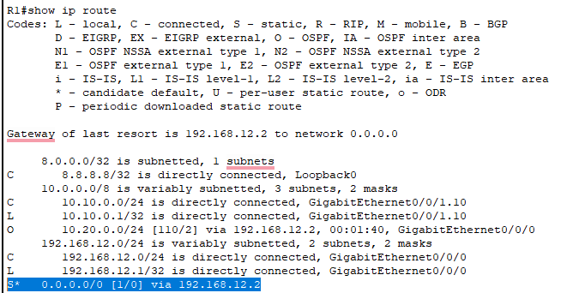

Qua router R2 để kiểm ra :

**show ip ospf neighbor**

**Ta thấy R2 đã nhận quảng bá default route ở interface G0/0/0 của R1**

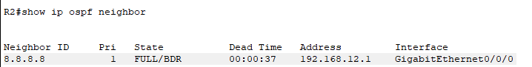

show running-config

show vlan brief

show interfaces trunk

show ip route